Can Carts

Introduction

This article is about making three carts from three cans.

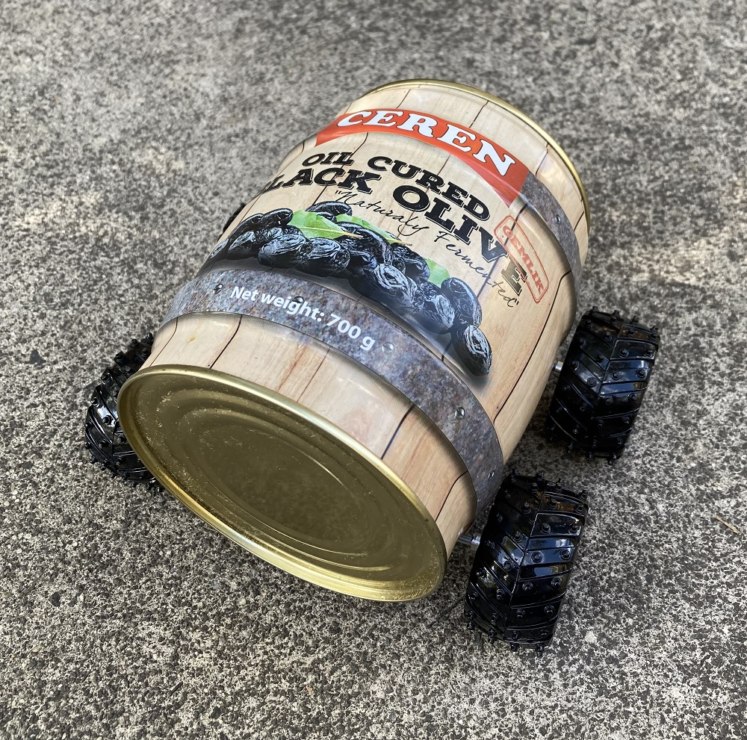 | 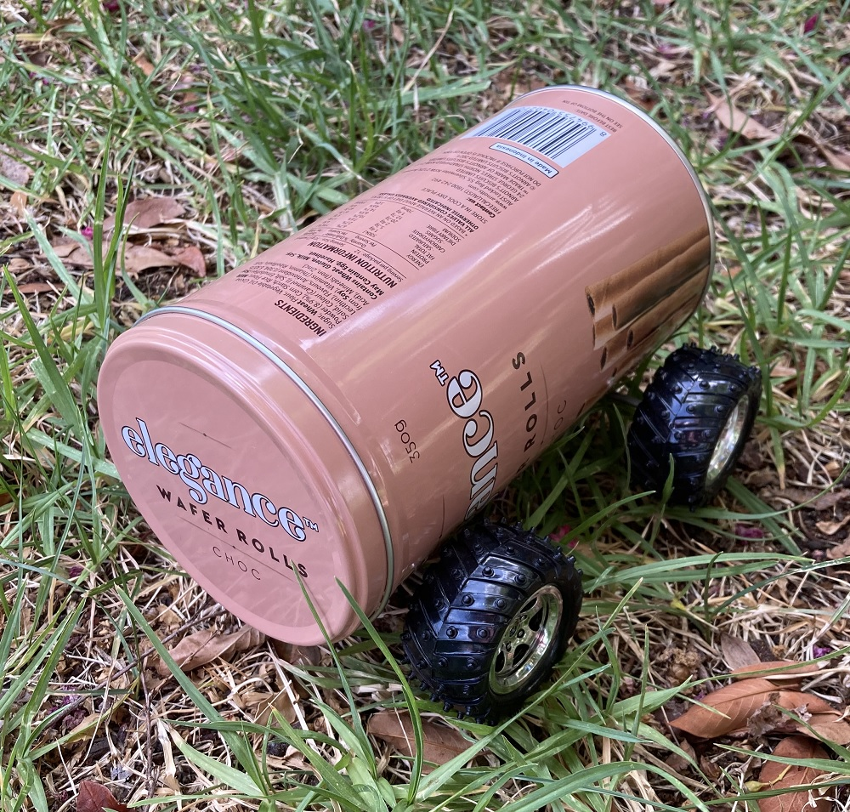
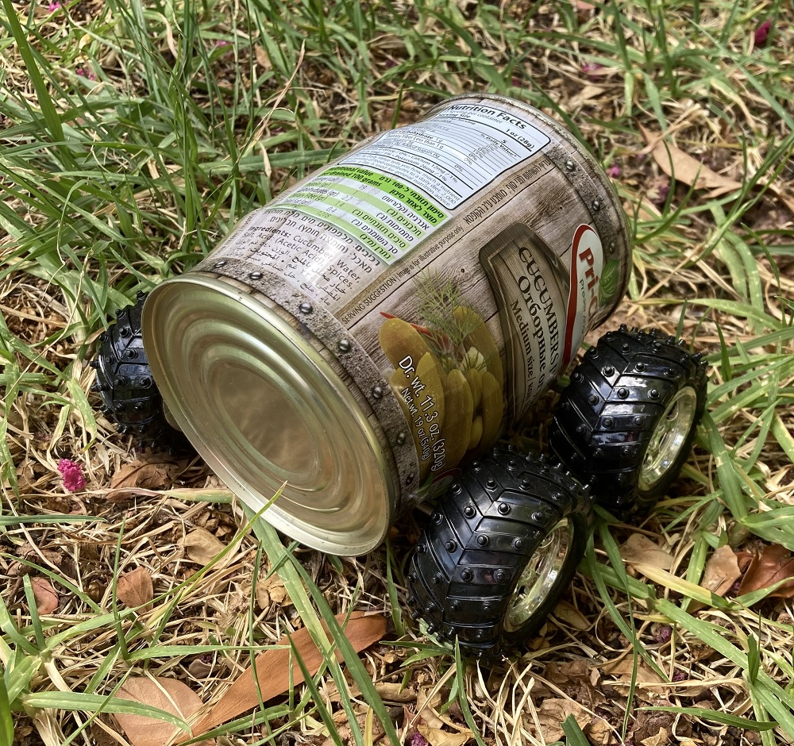
Figure 1: Can Carts.

Components

You will need the following items:

 | 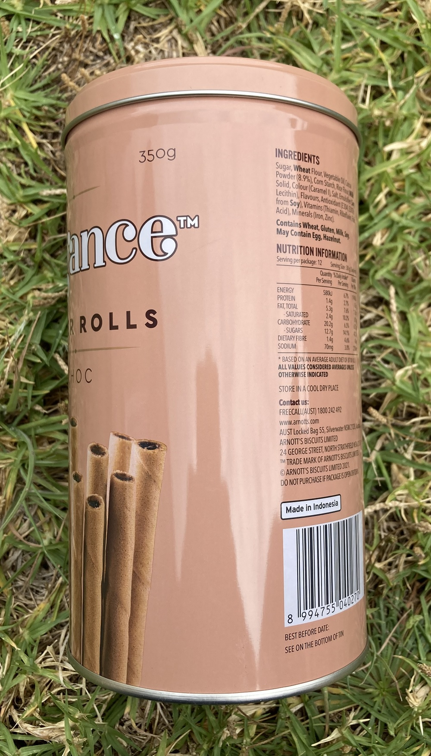
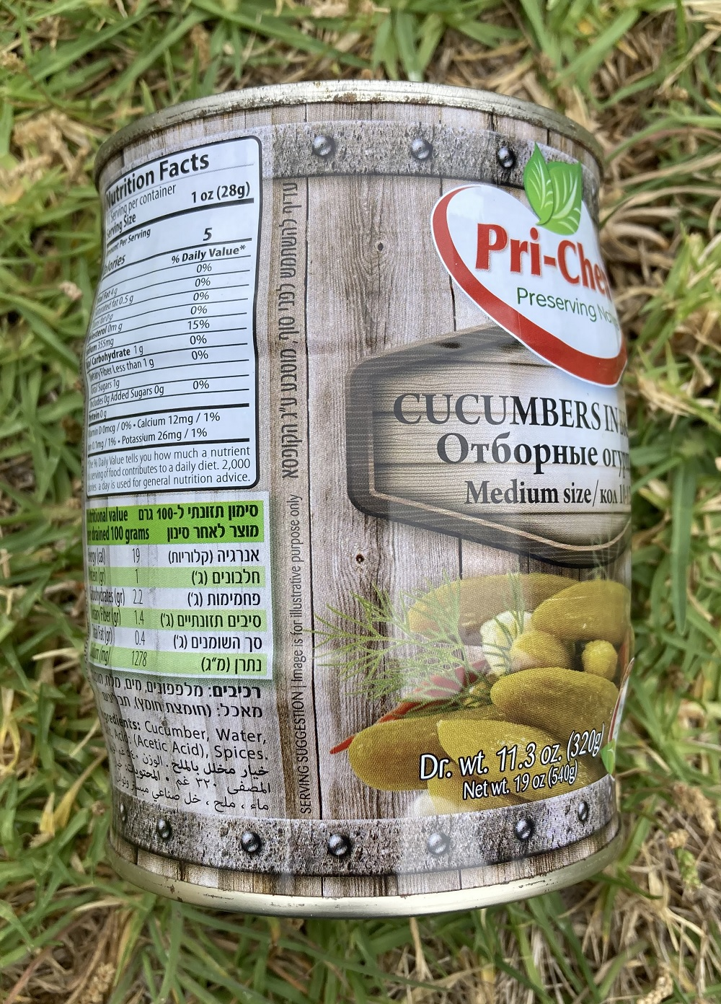
Figure 2: Components.

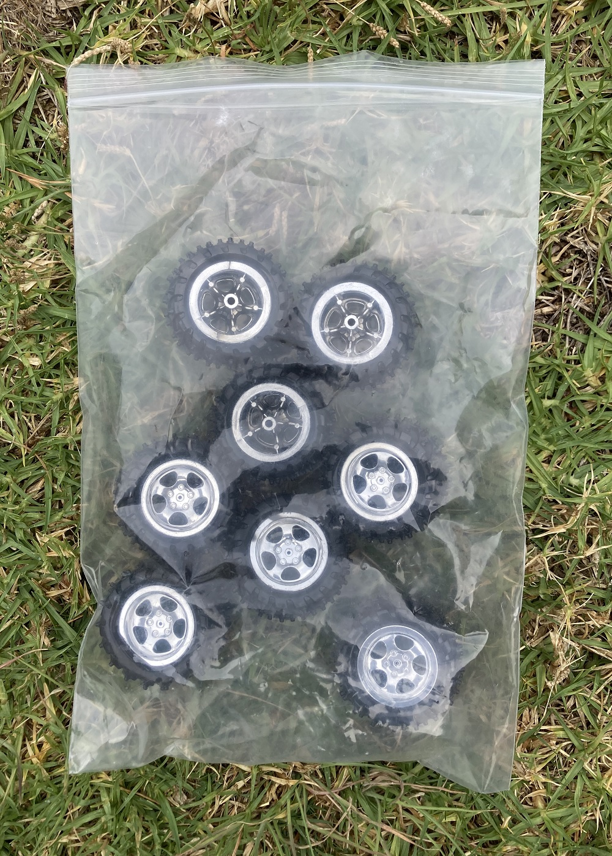 | 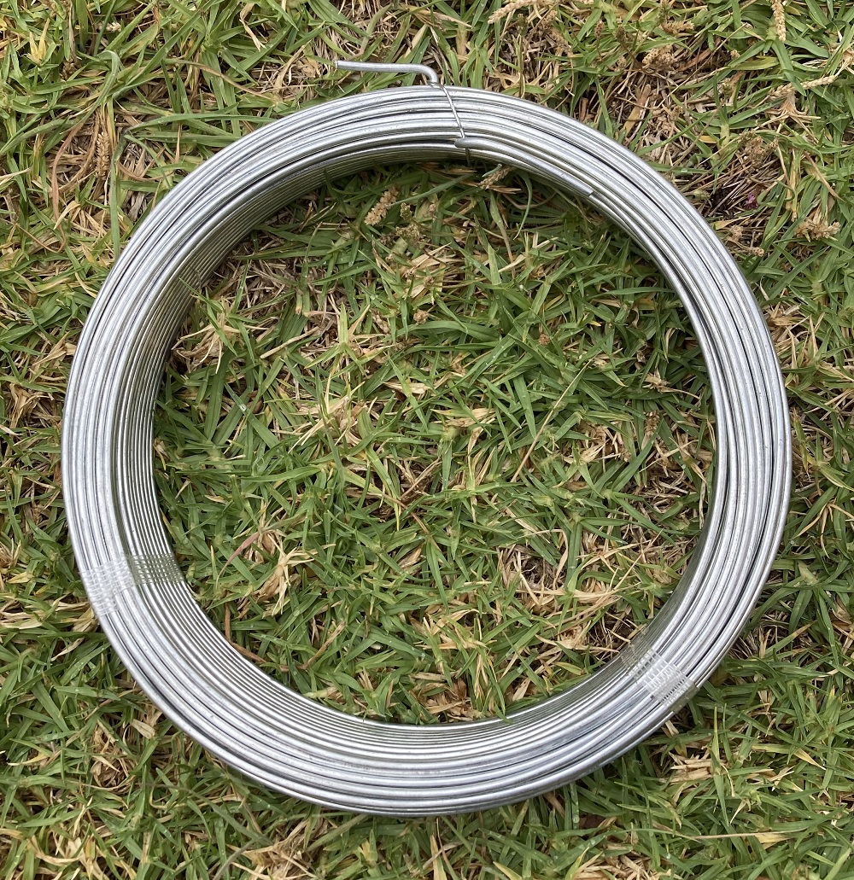
Figure 3: Components.

Tools

You will need the following tools:
- Permanent Marker,
- Hammer,
- Nail,
- Scissors,
- Pliers

Step 1: Mark the Holes

Mark the holes with a permanent marker:

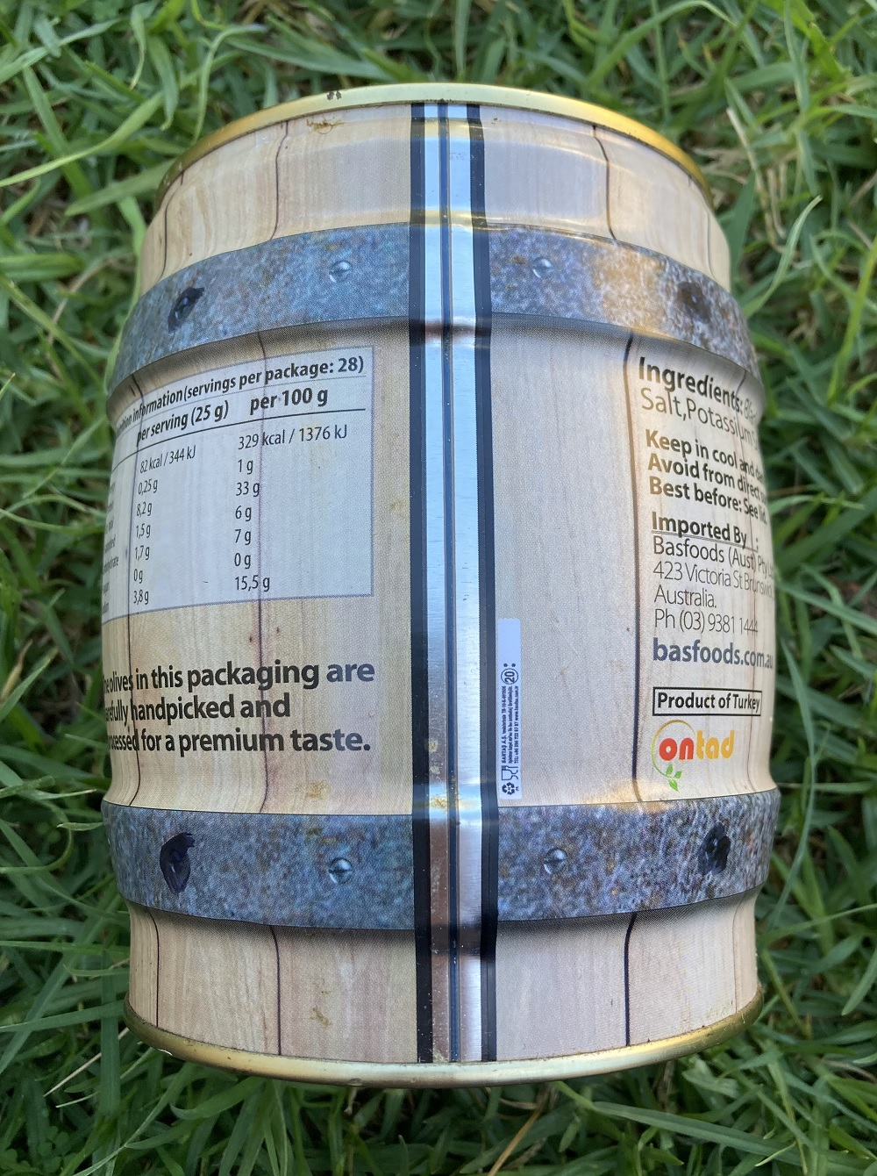 | 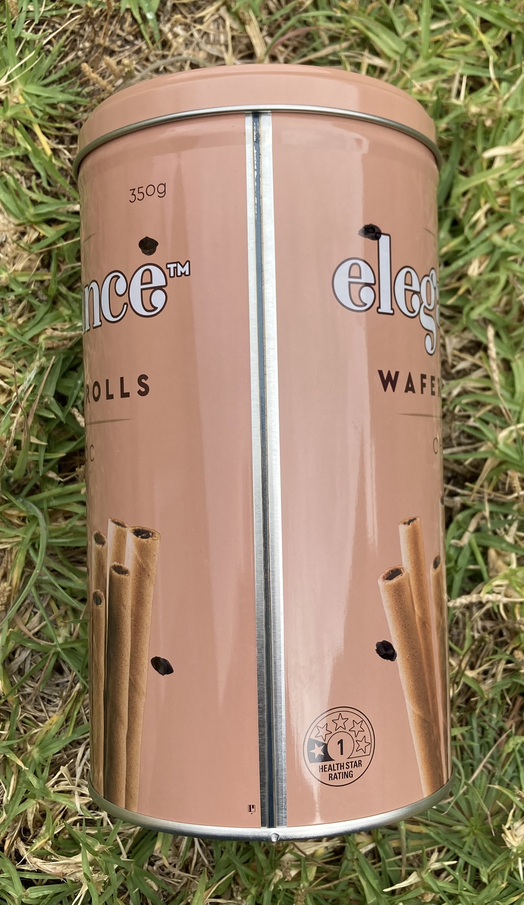
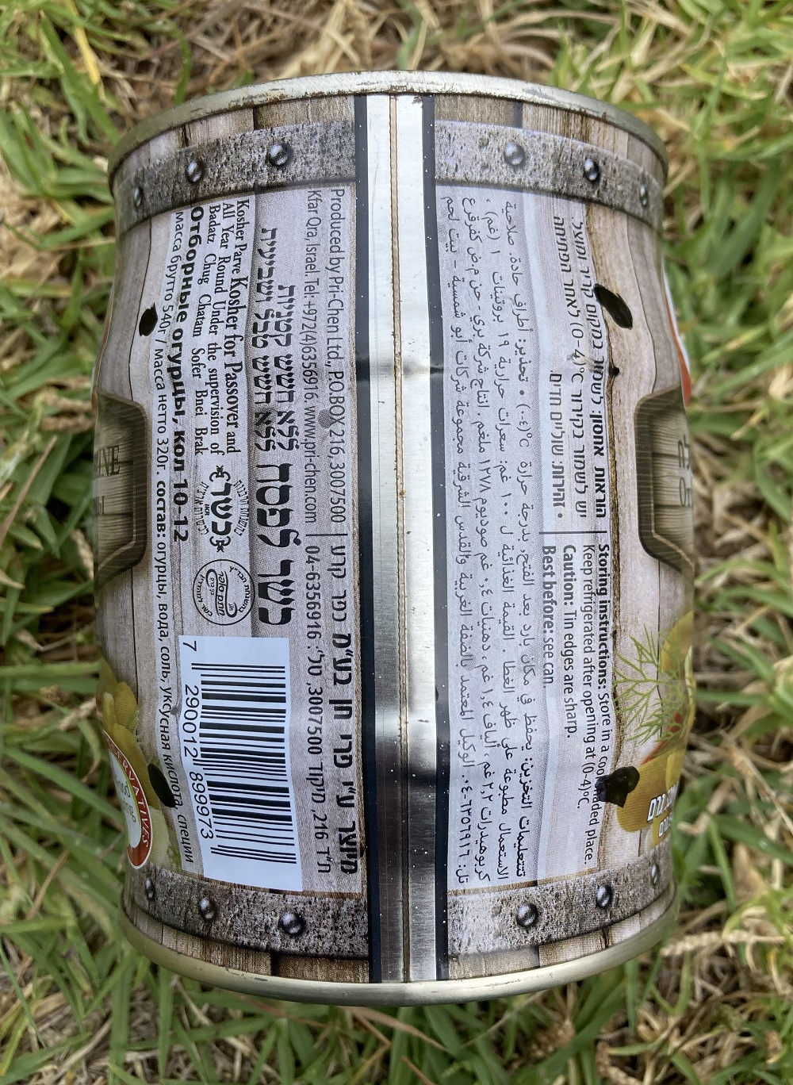
Figure 4: Make the Holes.

Step 2: Punch the Holes

Punch the holes with a hammer and a nail:

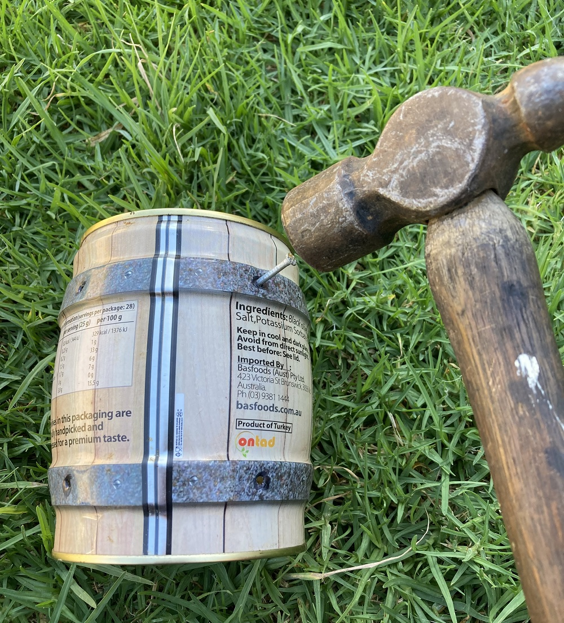 | 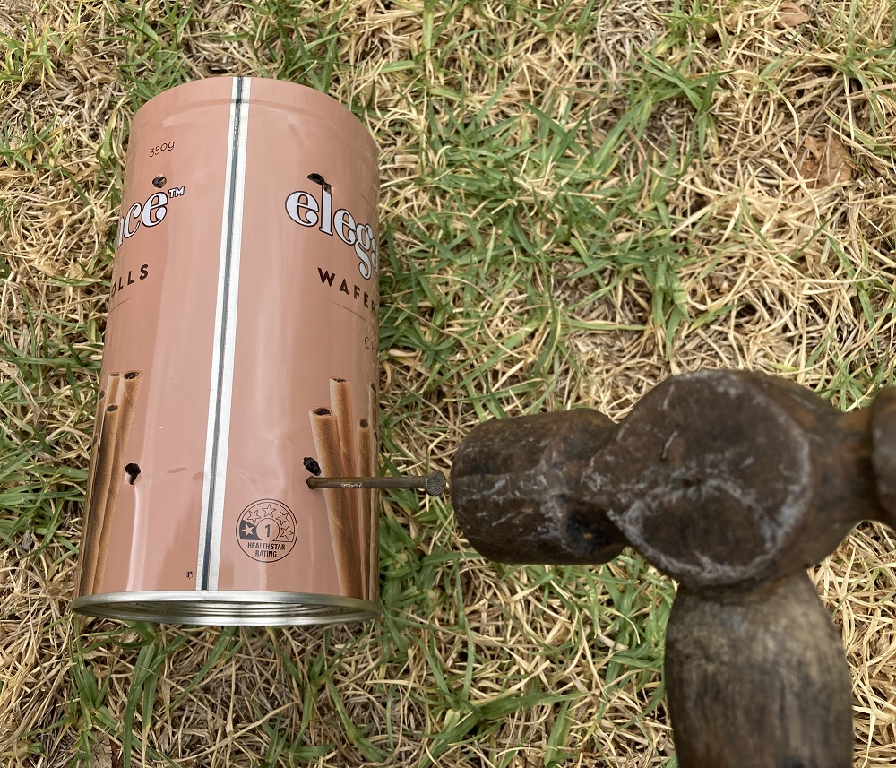
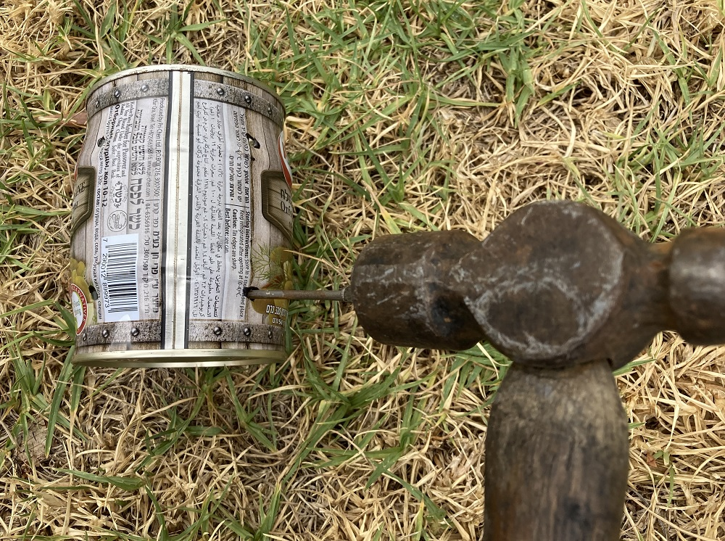
Figure 5: Punch the Holes.

Step 3: Widen the Holes With Scissors

Widen the holes with scissors:

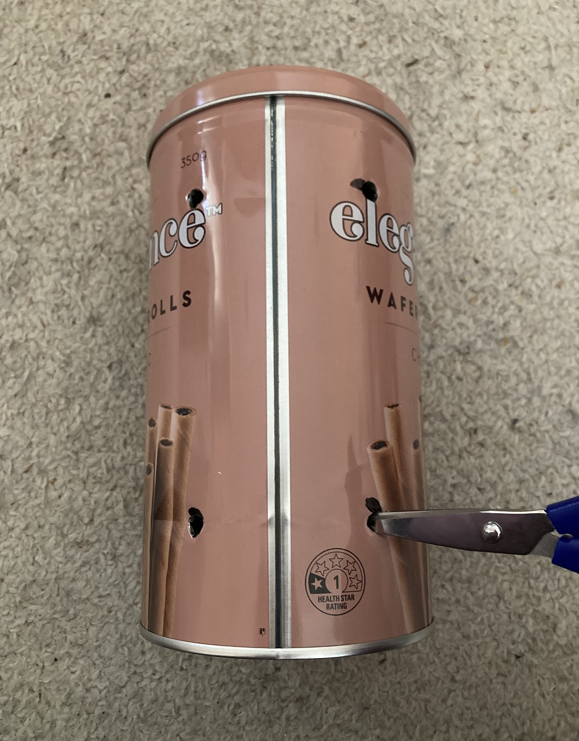 | 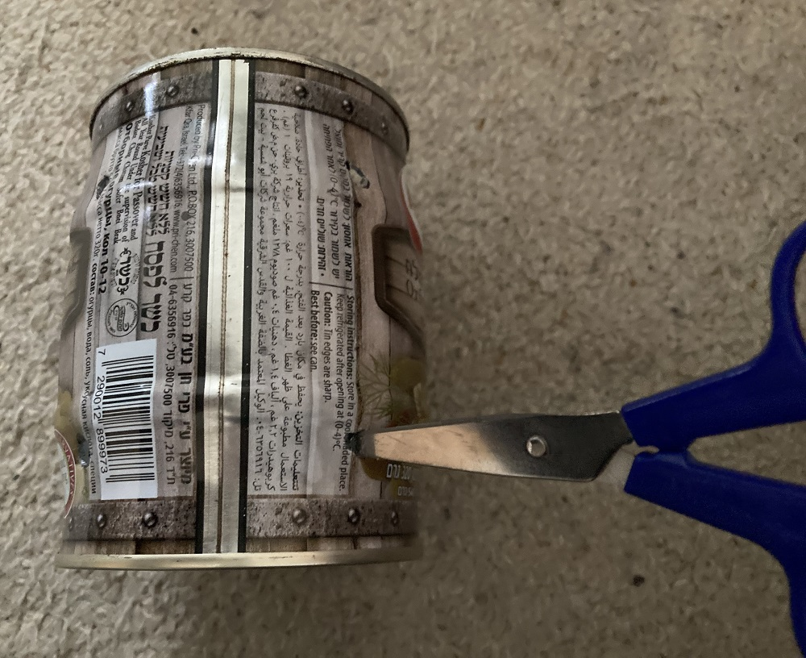
Figure 6: Widen the Holes.

Step 4: Attach the Wheels

Cut the metal wire with pliers and attach the wheels on both sides.

Discussion

I purchased the metal wire after buying the wheels, because I wanted to ensure that the metal wire was neither too thin nor too thick for the wheels.

Conclusion

The can carts work well. You can see them working in those YouTube videos:

https://www.youtube.com/shorts/imcb51nvceU

https://www.youtube.com/shorts/cjloptZ74Vg

https://www.youtube.com/shorts/zLWFCy4SNPc

